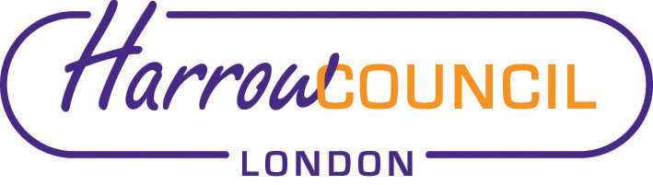
Harrow SACRE Meeting

Tuesday 10 December 2019 at 7.30 p.m.
To be held in Members lounge Note change of venue.
Harrow Civic Centre
Enquiries & apologies to:
Vivian Wright, Clerk to SACRE
vmwright@waitrose.com

Adviser to SACRE: Lesley Prior

Agenda
- Welcome:

- Apologies for absence: Camilla, Angella, Teri-Louise, Mohamed Amar

- Minutes of the last meeting on 15 October 2019: to agree the minutes as a true record.

- Matters arising from the minutes

- Monitoring of syllabus and websites: website reviews in light of new Ofsted
Inspections

- News from NASACRE

- Annual report 2018-19

- Determinations

- Marlborough Determination

- Collective Worship working group

- Report on Current Legal Arrangements for RE in Schools: https://researchbriefings.parliament.uk/ResearchBriefing/Summary/CBP-7167

- News from Faith Groups relating to schools

- Any Other Business

- Future Dates
- Tuesday 24 March
- Proposed future dates for 2020-21
- Wednesday 24 June 2020
- Wednesday 30 September 2020
- Tuesday 8 December 2020
- Wednesday 10 March 2021

